**CREATE AN ANALYSIS(SUPPLIER REAL TIME)WITH TWO COLUMNS(SUPPLIER NAME,SUPPLIER NUMBER)**

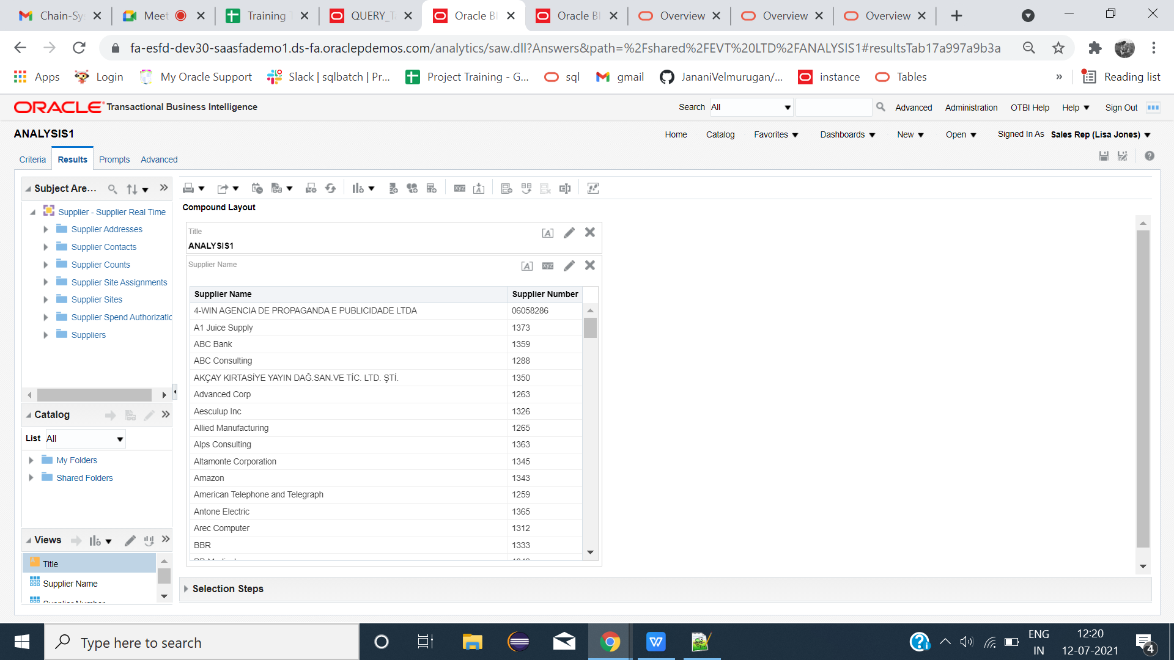

**Create Two tables(1.SUPPLIER NAME,2.SUPPLIER NUMBER).**

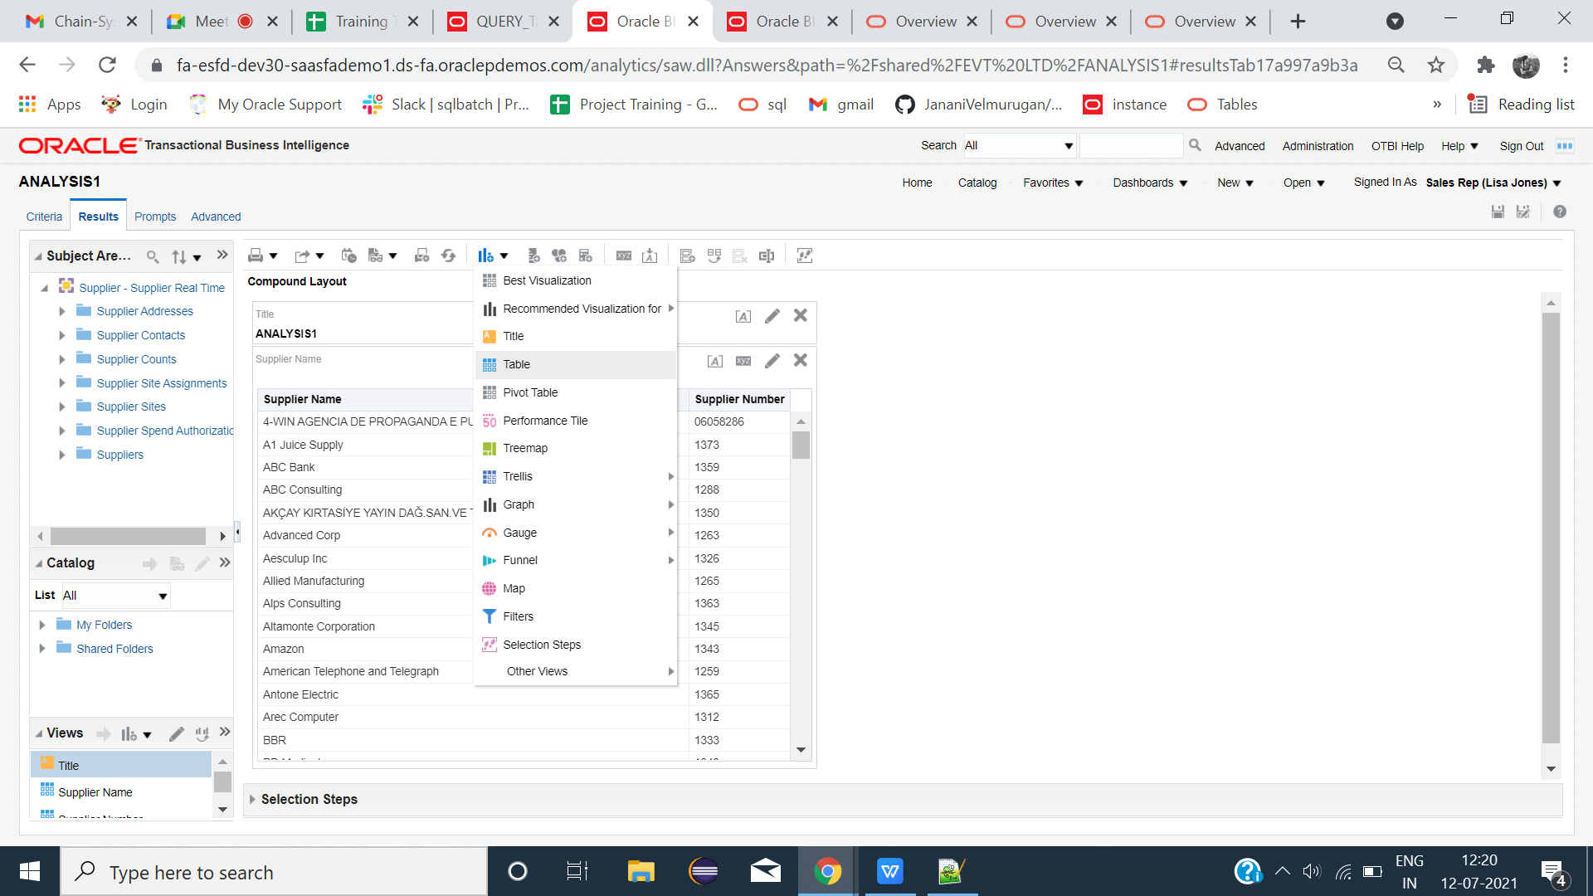

**IN TABLE 1 : SUPPLIER NAME (EXCLUDE SUPPLIER NUMBER)**

**IN TABLE 2: SUPPLIER NUMBER(EXCLUDE SUPPLIER NAME)**

|  |  |
| --- | --- |
|  |  |

**Rename the corresponding table NAMES**

**TABLE 1: SUPPLIER NAME**

**TABLE 2: SUPPLIER NUMBER**

**TABLE 3: BOTH(ALREADY CREATED IN FIRST)**

|  |  |
| --- | --- |
|  |  |

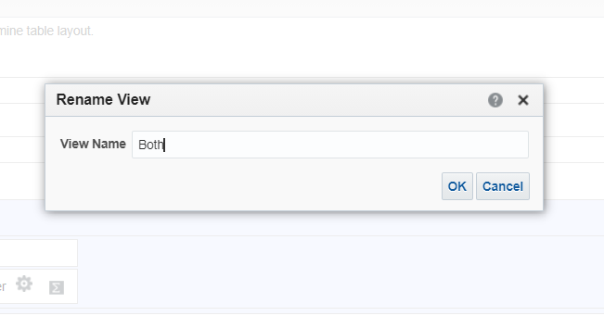

**Click graph icon->Other views->View selector**

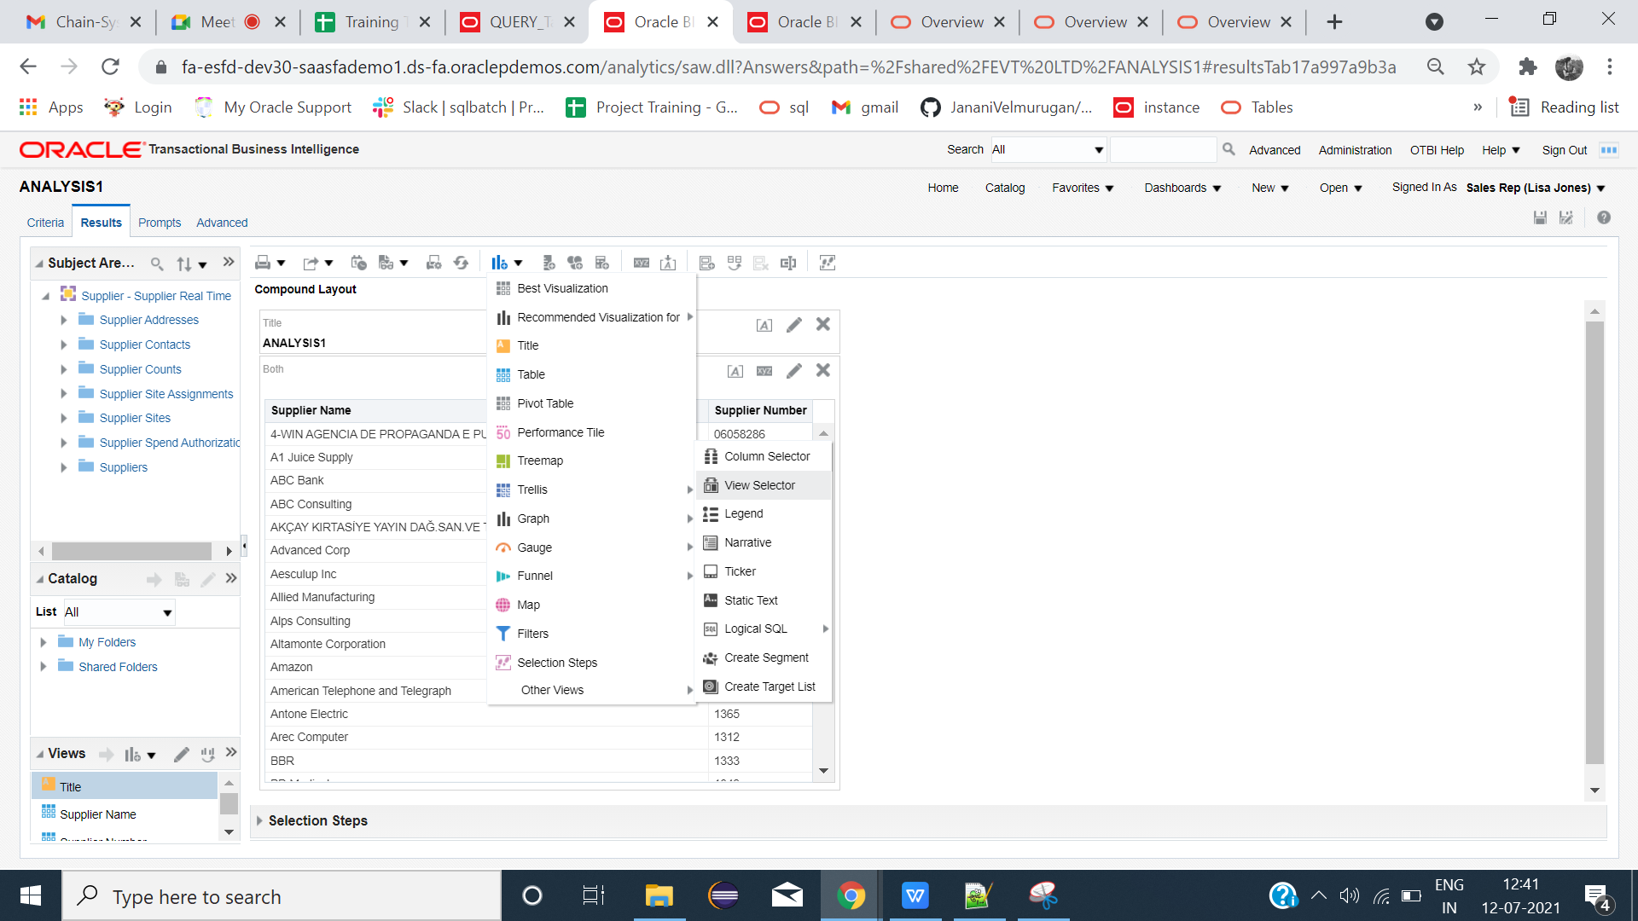

**INSIDE THE VIEW SELECTOR -> INSERT THE TABLES.**

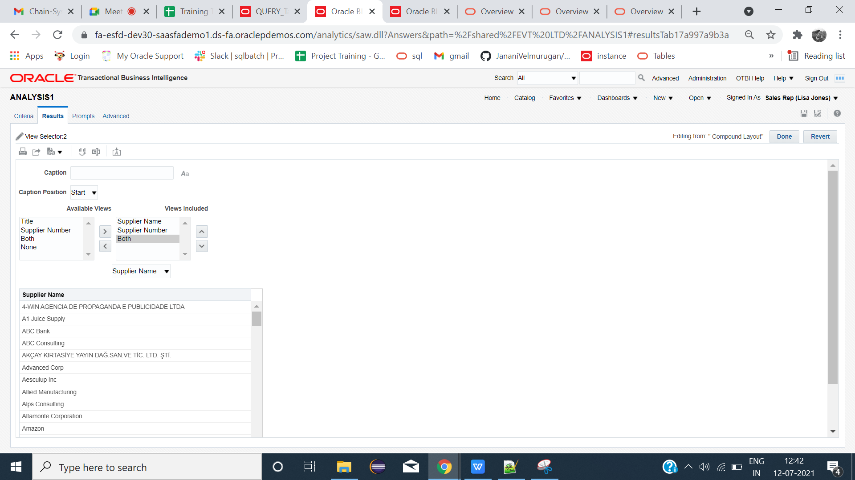

**Remove SUPPLIER NAME TABLE,SUPPLIER NUMBER TABLE,BOTH TABLE FROM RESULTS except view selector.**

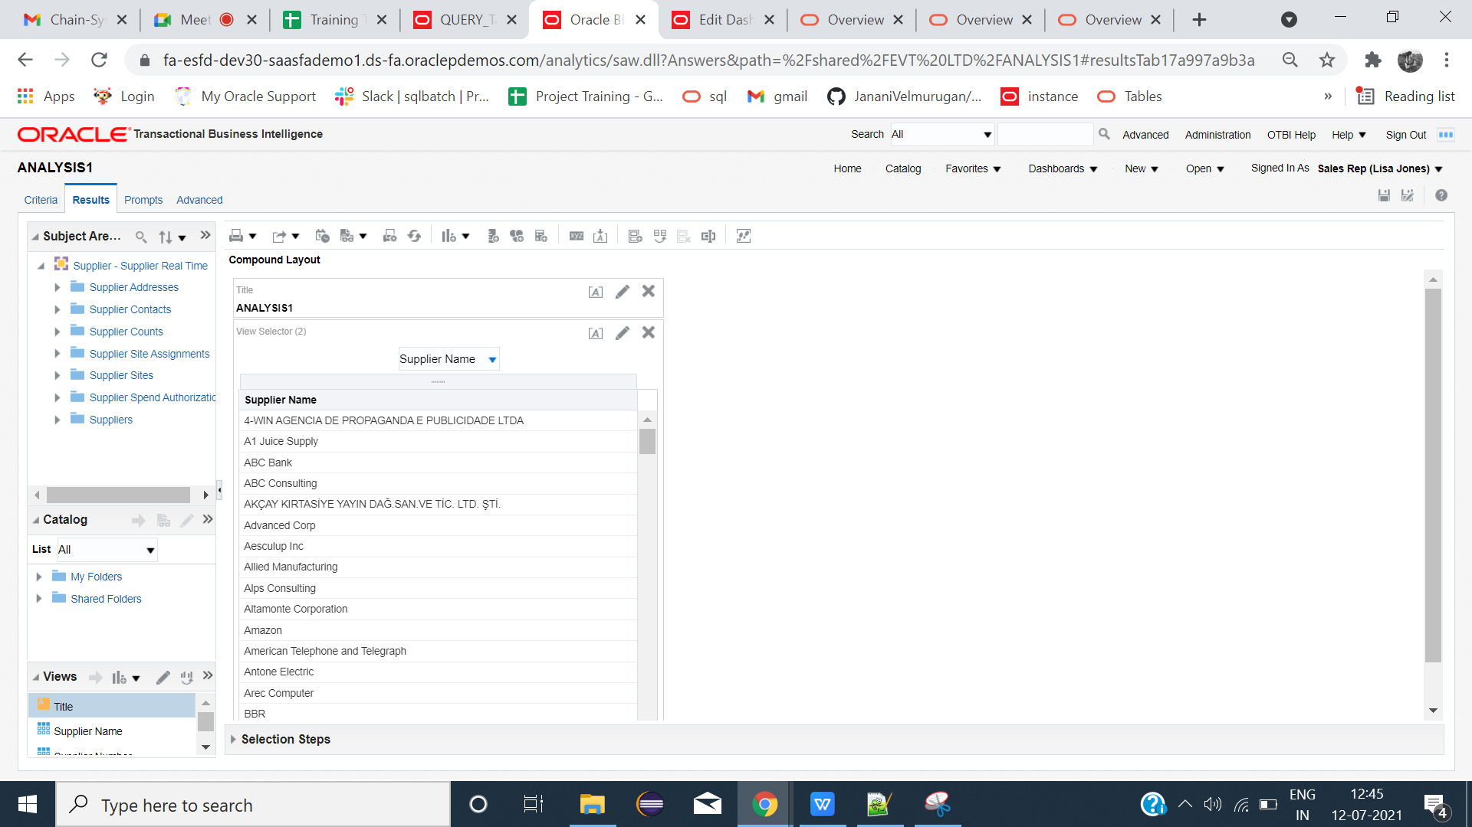

**Create dashboard and insert the analysis-->save-->Run**

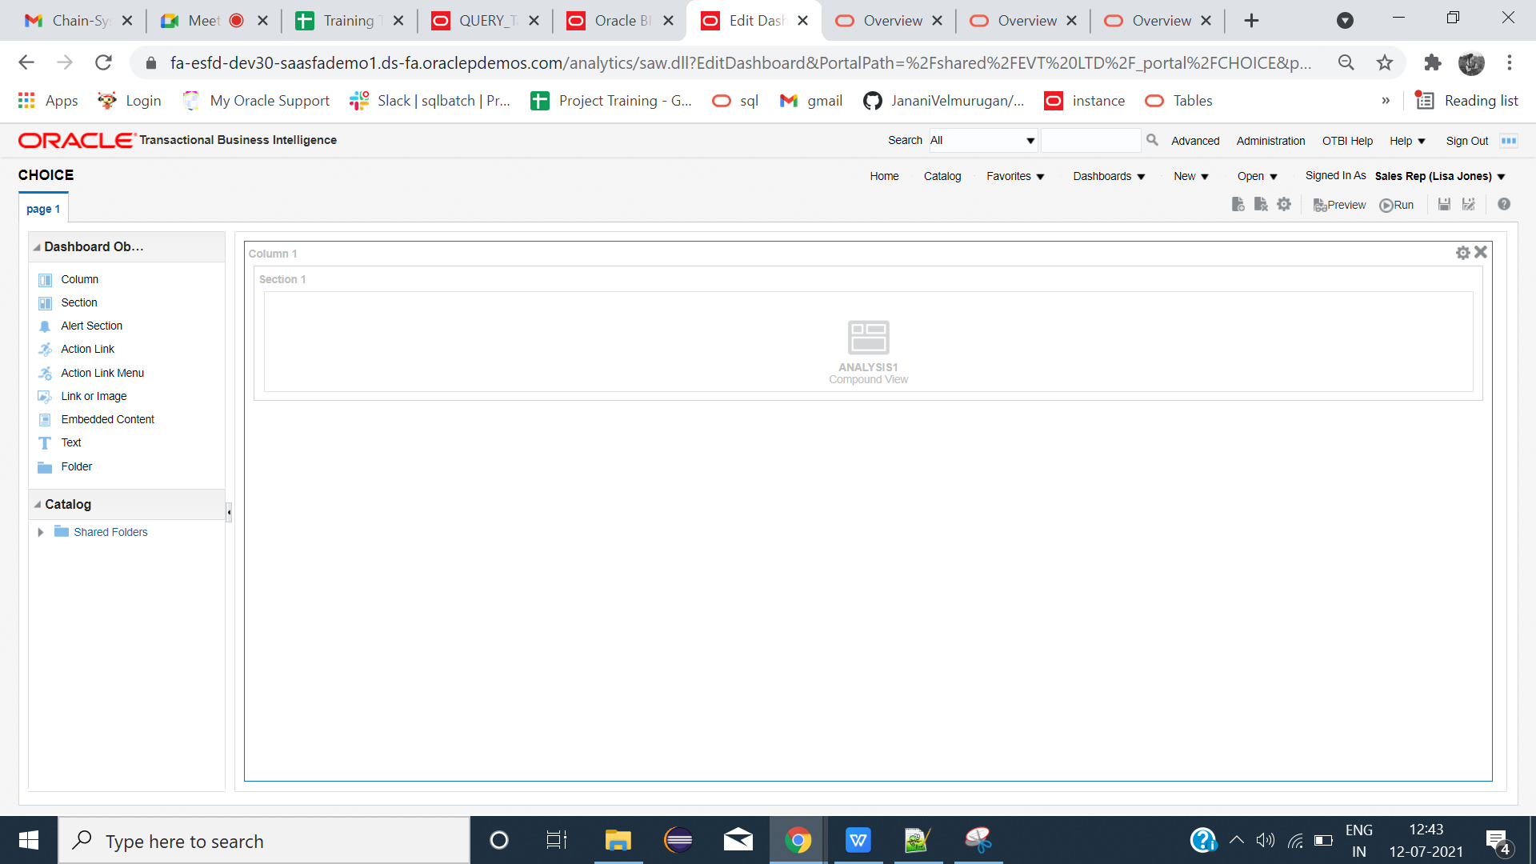

**OUTPUT:**

**Select the needed tables**

